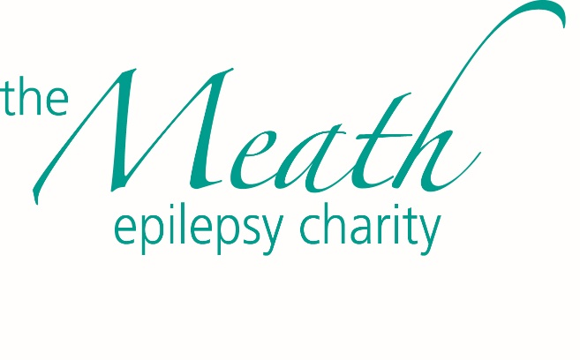
COVID-19 Visiting Policy- Relatives & Essential Workers Only

Please note that in the interests of the health and well-being of the people we support and our staff, we are allowing relatives by appointment only to visit The Meath. Relatives are not permitted to enter the houses but may use the gardens. Pick up and drop up is from outside the house. For information on how to book a time and the procedure to follow for visiting please contact the relevant House Manager or Tracy Toth our Registered Manager tracyt@meath.org.uk

The only other visitors permitted on site are those conducting essential works and these visits should be arranged through Richard Kirby the Estates Manager.

If you do not know who to contact regarding your visit enquiry, please contact Reception on 01483 415095. If you would like to see the infection control policy that we have in place for the people we support and staff please contact Tracy Toth, Registered Manager tracyt@meath.org.uk

Thank you for your understanding and stay safe.

The Meath Senior Management Team

